Departement of Informatics and Management
course: INFORMATICS
speciality: COMPUTER SCIENCE

Master thesis

Software looper pedal - a system for looping sound layers

Vysochynskyi Oleksandr

Key words:
MUSIC LOOPIG PEDAL
TOUCHLESS CONTROL
WEB CAMERA
short summary:
Master thesis contains the description of existing loopers and the idea of creating the software program which can replace the analog tool. The experiments described in thesis were performed with the help of up-to-date touchless technologies.

Supervisor | dr inż.Marek Kopel | ....................... | .......................
Supervisor | title, name and surname | mark | signature

Do celów archiwalnych pracę dyplomową zakwalifikowano do:*
- kategorii A (akta wieczyste)
- kategorii BE 50 (po 50 latach podlegające ekspertyzie)
* niepotrzebne skreślić

pieczątka Instytutu, w którym student wykonywał pracę

Wrocław 2014

Content

1 Introduction
1.1 Overview of the work
1.2 Theaimof the project
1.3 Motivation for creating
2 Background
2.1 Overview
2.2 Typesof loopers
2.3 Software looper
2.4 Theuse of loopers
3 Market research
3.1 General overview
3.1.1 TC Electronic Ditto Looper
3.1.2 DigitechJamman Express XT
3.1.3 Boss RC-3
3.2 Comparison
4 Software looper
4.1 General information
4.2 Mobius
5 Program description
5.1 Looper description
5.2 PCM format description
5.3 OpenCV description
5.4 Adding the library Open CV to SDK QT
5.5 Description and conversion RGB in HSV
5.6 Object detection
5.7 Acceptations of movements
5.8 Interface and main functions
6 Tests and comparisons
6.1 Resolution
6.2 Light intensity
6.3 Tested objects
6.3.1 Shape of the object
6.3.2 Slope of the object
6.3.3 The texture of the object
6.3.4 The colour of the object
6.4 Results of experiments
6.5 Comparison with similar programs
6.6 Tests with real users
7 Conclusions
Table of contents
List of figures
List of tables
References

Section 1
Introduction

The introduced document describes the practical realization of the program which performs a function of analogue sound looper controlled by web camera. The idea of ​​creation was the desire to use the capabilities of existing solutions combined with up-to-date way of control.
This section refers to the main goals of the selected project as well as the extent of further work.

1.1 Overview of the Work
The master’s thesis contains the description of the project with all the issues faced during its creation. Also, there are some examples of program’s functions and problems which could bevital obstacles during the first usage.
The work is divided into two main parts:
- analytical(market research and the foundation of the contemporary algorithm for touchless control based on software program regulation using web camera). First, it is necessary to analyze the problem basing on different aspects. During this, I plan to make a research of market, analyze all types of products, find some aspects that can be improved. Then, it will be easier to find the proper algorithm and best options for the program. Only under such conditions it will work exactly as it was planned.
- Practical developing the application itself with its core function – to create and repeat the sound with was recorded before).Second part is implementation of task, that will be set in the analytical part. In this par, I will concentrate on chosen aspects, create a project and implement it in a prototype.

1.2 The Aim of the Project
The most important aim is the elaboration and setup of the application created for the realization of sound looping function with the help of the web camera. The program has a function of recording and replaying the sound for its next repetitions. Realization is made with the help of computer without any extra devices.
First of all, it may be useful for the musicians-amateurs in order to fasten the recorded track so that it could be repeated as many times as it is wanted. The point is to make it convenient for the usage while playing the instrument. Also, it must be acceptable for the average person to get used to it in order to have benefits from playing.
Second of all, the experiment on the new way of using web camera and touchless control helps to develop tools for transforming gestures into specified command combinations. Nowadays, it is rather profitable business and there is a possibility to develop it in the future. This program for sound looper is the first step for new look at an old problem, a new breath of trivial idea.
What is more, project shows the opportunities of new software technologies in comparison with the classical analogue devices. Less efforts is needed to record the sound via digital tool than the analogue one.

1.3 Motivation for Creating
Era of digital world induces to create more useful devices in order to ease people’s lives. It turns to be much more complicated to use ordinary tools when everything is computerized and society tends to search for everything in the Internet. Nowadays, an average person turns to the Internet almost in every situation and having any question. This means that inventing a software sound looper will be accepted by people who use an analogue one as it will have a stunning effect on their productivity.
This program can also be the next step on the way of developing touchless device control; it shows its possibilities and perspectives for the similar programs.
There is a great variety of analogue loopers within device market. Prices and characteristics are different but there are lots of drawbacks. This causes a great need in software loopers with better options and easier conditions for working.
One of the vital problems which are faced during the usage analogue device is the functional limitation. Expanding the opportunities is limited because of the properties of elements. While enlarging the functions of analogue looper, the amount of its elements also increases. This makes the product more expensive and less popular among customers. In addition, the more elements the less reliable they are.
The master thesis is based on the software program which is predicted to ease playing the music with different special effects. The motion recognition is the best option for such a program as it allows to perform basic functions without touching with free hands and feel all the benefits of working with software version.
Modern computer vision research has its origins in the early 1960s. The earliest applications were pattern recognition systems for character recognition in office automation related tasks (…). Early work by Roberts in the 1960s first identified the need to match two-dimensional features extracted from images with the three-dimensional representations of objects. Subsequent research established the practical difficulties in reliably and consistently accomplishing such a task, especially as the scene complexity increased, as the illumination variability increased, and as time, cost, and sensor noise constraints became more prevalent.
Early systematic work on vision systems is also traced to the Hitachi labs in Japan where the term machine vision originated, to distinguish its more pragmatic goal of constructing practical applications, as compared to the more general term computer vision, popularly used to also include less pragmatic goals. An early research thrust in 1964 involved the automation of the wire-bonding process of transistors, with the ultimate goal of replacing human workers. Even though the automated system achieved 95% accuracy in lab tests, this was deemed too low to replace human workers. By 1973 however, fully automated assembly machines had been constructed, resulting in the world’s first image-based machine for the automatic assembly of semiconductor devices. Arguably, the most successful application of machine vision technologies is in the assembly and verification processes of the semiconductor industry, enabling the mass production and inspection of complex semiconductors such as wafers. Due to the sheer complexity of this task, human workers could not have possibly solved such problems reliably and efficiently, thus demonstrating how vision technologies have directly contributed to many countries’ economic development by enabling the semiconductor revolution experienced over the last couple of decades.
(…)Recognition technologies are also successfully used in the food industry (e.g., for the automated classification of agricultural products), the electronics and machinery industry (for automated assembly and industrial inspection purposes), and the pharmaceutical industry (for the classification of tablets and capsules). Many of the models used for representing objects are also effectively employed by the medical imaging community for the robust segmentation of anatomical structures such as the brain and the heart ventricles. [8]

The above facts indicate that the use of computer vision and machine started long ago, but its wide proliferation, we can observe just recently.

Section 2
Background

2.1 Overview
A looper pedal or "phrase looper" allows a performer to record and later replay a phrase or passage from a song. Loops can be created on the spot during a performance (live looping) or they can be pre-recorded. Some units allow a performer to layer multiple loops. The first loop effects were created with reel-to-reel tape using a tape loop. High-end boutique tape loop effects are still used by some studios who want a vintage sound. Digital loop effects recreate this effect using an electronic memory.[7]
Nowadays, analogue loopers are leaders on the device markets. The companies bring out vast amount of similar products, starting from the simplest ones to the multifunctional, sophisticated systems with the opportunity to expand their options. Talking about loopers, there are some pros that should be noticed: firstly, their small dimensions and reliability; secondly, simplicity in usage and comprehension, user-friendliness and no need in using computer.
On the other hand, these tools have some cons, including lack of built-in power supply unit (the portable one is not put even in set), limited functionality, effects, settings, the number of tracks and even the duration of the recording.

2.2 Types of loopers
There are two main types of loopers:
- separate devices in the individual corps with the hardly specialized functionality
- computer programs which allow carrying on the same functions, using the opportunities of PC.
The last ones differ by the ability of creating almost unlimited number of loops, length of which is limited just by the ability of operating the information, especially the volume of PC’s memory. One more reasonable advantage of computer programs is the ability of enlarging the functional without any extra expenses. The computer version of looper can have a great amount of tools for editing, ready sound effects, the ability to carry on the operations separately with each recorded track, separate volume control for different tracks, functions of equalizer.

2.3 Software looper
The benefit of computer program is the opportunity using the looper without any extra equipment. Average computer with the sound card is enough. With the help of mouse user chooses the necessary mode, wanted characteristics and functions. All the program management is done via base computer tools, without need of buying special devices.
This way has its advantages, but also its disadvantages. To the last ones can be taken:
- sound card, usually more concentrated on the recreation of sound, not on the recording
- majority of standard sound cards can’t provide with good clarity and sound quality
- management with the help of mouse and keyboard is not convenient, doesn’t let the user start recording/playing in time
- computer is not usually equipped in typical music TRS cable connectors, so adapters are needed.
There are lots of loopers lately, everyone can choose the best one for himself – by price and characteristics.
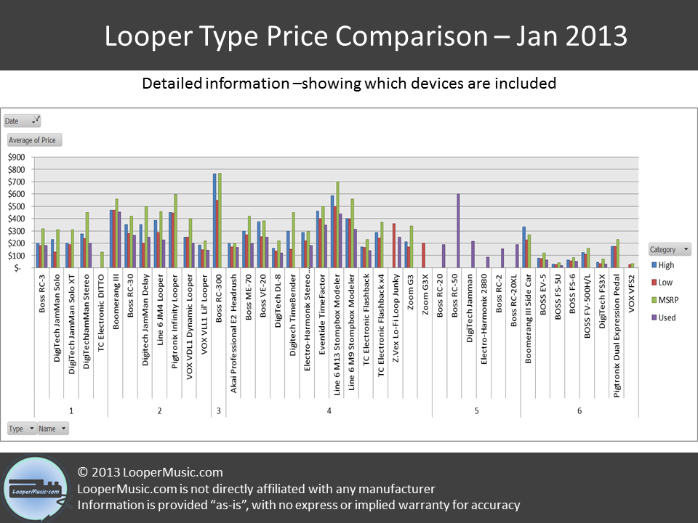
Figure 2.1 Looper Price Comparison
http://loopermusic.com/wp-content/uploads/2012/12/Detailed-Looper-Type-Price-Comparison-Jan-2013.png
It is a common situation when the simplest loopers are placed in the sophisticated devices. Some models have extra inputs for recording samples from the microphone, CD or MP3 player in order to mix it with guitar later. Variety really impresses.

2.4 The use of loopers
There are different reasons for using one of those tools – it depends on person’s imagination. Most common reasons why people buy loopers are:
- solo practicing. It is obvious: chord track is recorded in order to loop it and practice playing solo version.
- rhythm practicing. Sometimes it is tough to keep rhythm the same during all the composition. Here looper can help – recording any track there is an option to switch on the rhythm control. Generally, it is very convenient to record the sound, listen to all the mistakes and try to avoid it later.
- creating the song. This reason is logical due to the previous ones. Musician records some sounds, edits them and if they are okay, saves them. Then, solo is created, some effects are added and the music is done
- playing the whole song without anyone’s help. Looper can replace the entire band.
Software loopers are more handy due to their ability of saving all the tracks and mixing them or changing some parts within one program.

Section 3
Market research

3.1 General overview
There are several types of analogue sound looper pedal. It’s important to start with the simplest ones.
These loopers differ in limited number of sound loops (from 3 to 5) and time length (up to 10-15 min). These devices have only several common functions such as recording and replaying sound, volume control and status indication. In the picture below there is one of the simplest tools for sound looping shown within the market.

3.1.1 TC Electronic Ditto Looper
This is a guitar looper, produced by TC ELECTRONIC, one of the world’s leader in music devices industry.
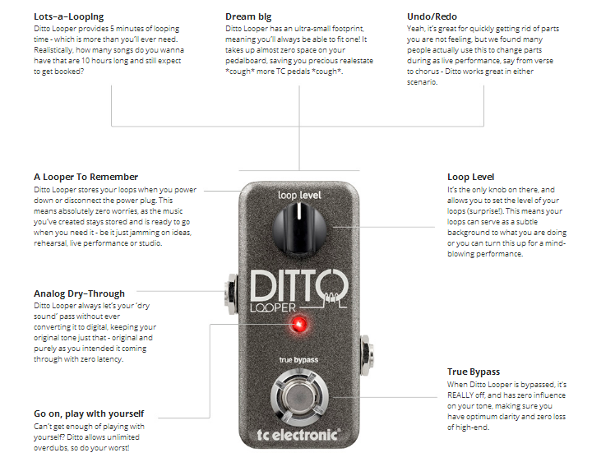
Figure 3.1TC Electronic Ditto Looper
http://www.tcelectronic.com/ditto-looper/

It contains:
- input Jack
- output Jack
- port USB
- main button/pedal
- volume regulator
Its size is only 3 5/8 "by 1 5/ 8"
Features of product:
- 5 minutes of looping
- Undo / Redo function
- Unlimited overdubs
- 24 bit uncompressed high quality audio
- Ultra-small footprint, requires 9V DC adapter
The construction of effects pedal is based on the new, up-to-date approach to the process of creating, which puts Ditto Looper one step forward from other similar devices. Functional ability is quite wide as it was created with the motto „for the guitarist from the guitarist”. Pedal can be used by different musicians – from drummers to vocalists.
The set of opportunities includes Bypass itself and absolutely analogue scheme (Analog Dry Through), which allows saving the sound signal in its original form.
There are some ways of setup the instrument to the looper. The simplest one is following:
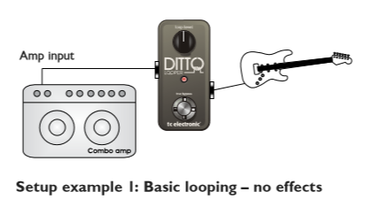
Figure 3.2 Setup example 1
http://www.tcelectronic.com/ditto-looper/

More complicated bond is:
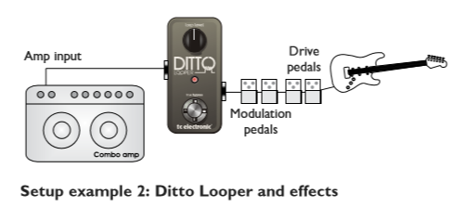
Figure 3.3 Setup example 2
http://www.tcelectronic.com/ditto-looper/

The effects should be put before the looper. This allows creating and recording various sounds during one looping session.
The most difficult way of connecting looper with the computer shown below:
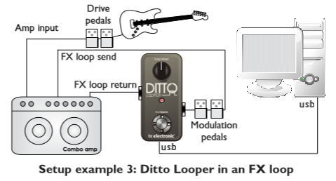
Figure 3.4 Setup example 3
http://www.tcelectronic.com/ditto-looper/

If there is an FX Loop, the modulation effects and Ditto Looper should be placed in that loop.
Brief information about this looper is written below.
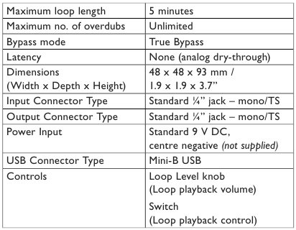
Table 3.1 Ditto Looper characteristics
taken from: http://www.tcelectronic.com/ditto-looper/

3.1.2 DigitechJamman Express XT
More complicated looper is DigitechJamman Express XT.
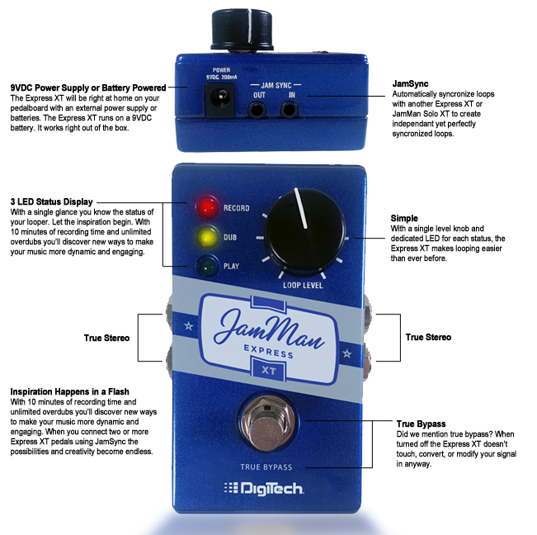
Figure 3.5 DigitechJamman Express XT
http://www.8thstreet.com/Digitech-JamMan-Express-XT-Full-Featured-Compact-Stereo-Looping-Pedal-pc68593.8

This is a little more complicated looper. It has ability to record up to 10 minutes of stereo sound, as well as more inputs/outputs. Also in case of mistake it is possible to erase only the last segment, rather than remove the entire loop.
The most beneficial feature of this product is the ability to connect between a few such devices to record really complex composition. The kind of chain is forming itself or can be chosen by user.
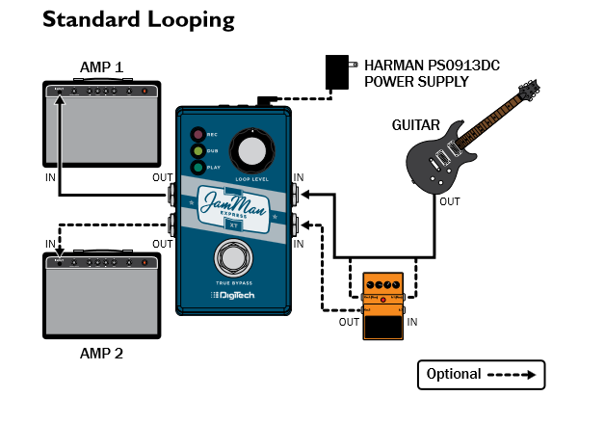
Figure 3.6 JamMan: Standard Looping
http://digitech.com/en-US/products/jamman
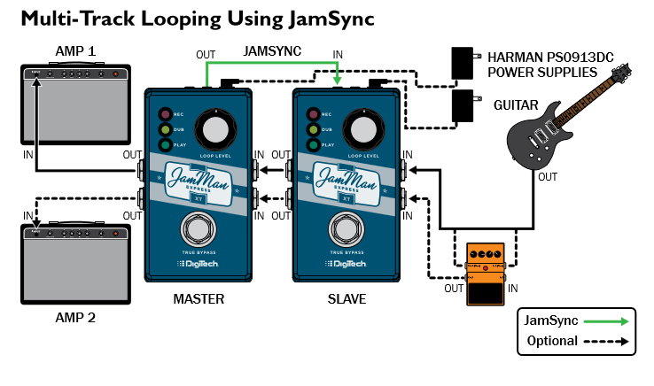
Figure 3.7 JamMan: Multi-Track Looping
http://digitech.com/en-US/products/jamman
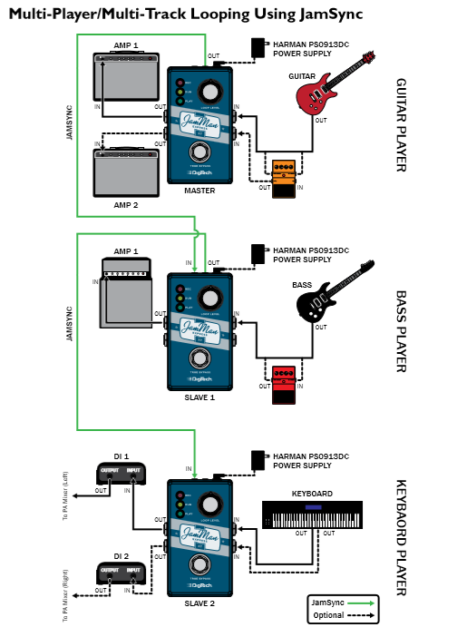
Figure 3.8 JamMan: Complex Connection
http://digitech.com/en-US/products/jamman

Features of product:
- 10 minutes of Stereo recording time
- True-bypass
- JamSync™
- Silent Clear™
- Separate LEDs for Record, Overdub, and Play Status
- Unlimited Overdubs with Undo and Redo
- Works with 9V battery or 9VDC Power Supply (sold separately)
- Durable metal chassis and footswitch

3.1.3 Boss RC-3
The next one which is worth checking is more improved version of sound looper, word leader of selling among professional musicians – Boss RC-3.
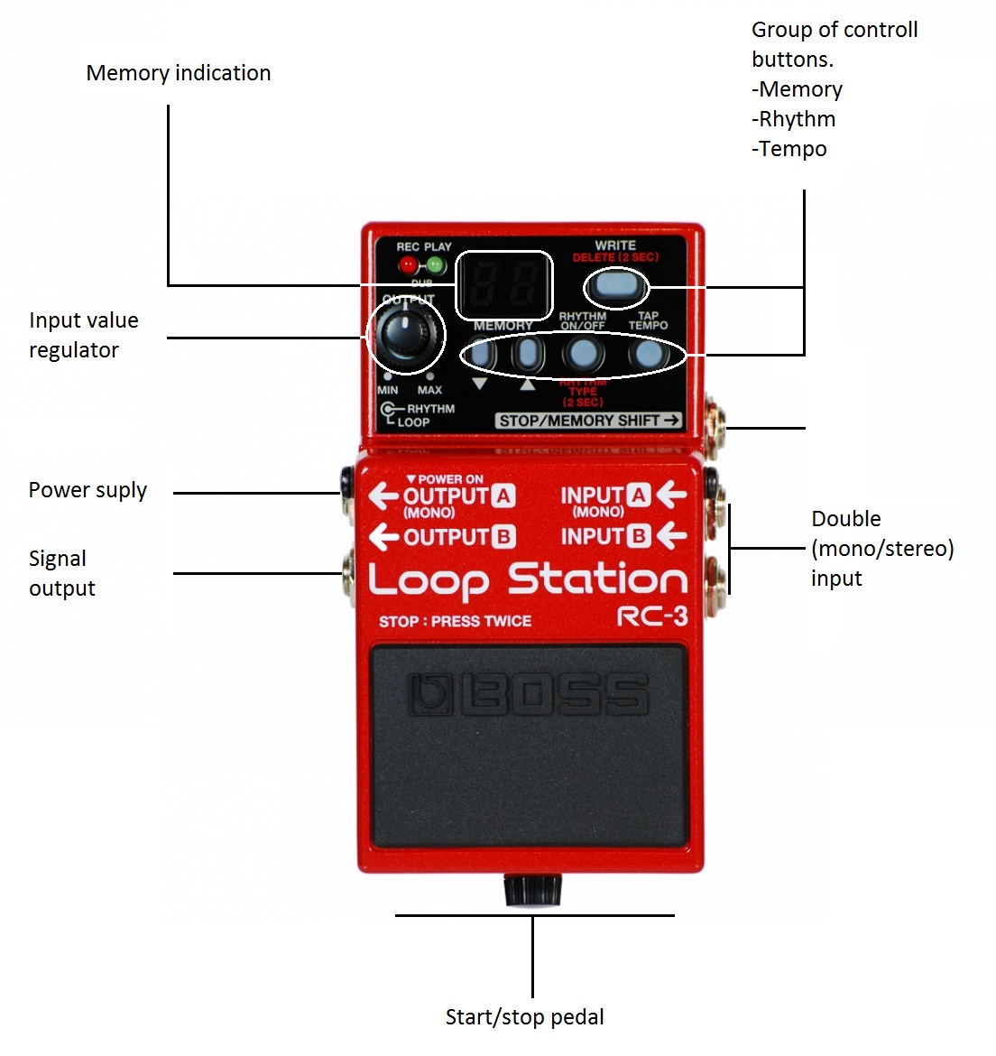
Figure 3.9 Boss RC-3
http://www.bossus.com

It is equipped with all necessary tools and put in a compact pedal. The recording time is enhanced – up to 3 hours of stereo recording, 99 loops can be saved, special options for drum rhythm and USB 2.0 compatibility – all this is included in the small device. Advantages of this product are great:
- memory up to 3 hrs of stereo recording
- saving 99 loops
- USB 2.0 port, connection to PC
- ability to save loops in WAV audio format
- rhythm guide (drums, etc.)
- 9-volt battery
- optional AC power supply
The benefit of this tool is a large memory. Now it is possible to save long phrases beyond doubts that it wouldn’t be saved. 99 memory locations let the musician create lots of soundtracks. The true stereo I/O will be valued by professionals.
There is a feature of auto recording which helps to record at the very moment the person begins playing guitar and starts a connected audio player. What is more, there is a count-in mode which gives one-bar of rhythm before recording begins. It is possible to undo or redo while playing. 3 hours of recording is also very essential moment.
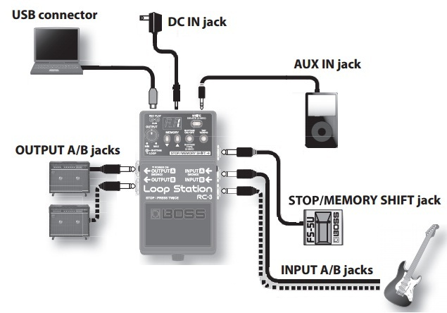
Figure 3.10 Boss RC-3: Connection
http://www.bossus.com

Rhythm guide plays a great role in the RC-3. It keeps the rhythm in time so that it would be less complicated to follow the melody. There are several options of rhythms in the library. 10 basic ones are provided, including Rock, Pop, Latin, etc. The tempo and the volume can be also regulated. When a phrase is saved, the rhythm type and time signature will be saved as well.
RC-3 can be connected to the PC via standard USB cable and save all the tracks in the computer folder for safekeeping. It can be done vice versa too – the sound files can be loaded from the computer directly into the RC-3. The RC-3 accepts 16-bit/44.1kHz WAV files of up to 1.7GB in size.

Nominal Input Level | INPUT: -20 dBu  AUX IN: -10 dBu
Input Impedance | INPUT: 1 M ohm  AUX IN: 22 k ohms
Nominal Output Level | -20 dBu
Output Impedance | 1 k ohm
Recommended Load Impedance | 10 k ohms or greater
Recording/Playback | Maximum Recording Time: Approximately 3 hours  Maximum Phrase Memory: 99 phrases  Number of tracks: 1  Data Format: WAV (44.1 kHz, 16-bit linear, stereo)
Rhythm Type | Hi-Hat, Kick
USB Interface | Hi-Speed USB mass storage device class
Controls | Pedal switch  LOOP OUTPUT knob  RHYTHM OUTPUT knob  DOWN button  UP button  WRITE button  RHYTHM ON/OFF button  TAP TEMPO button
Indicators | REC, PLAY (DUB) indicator
Display | 7 segments, 2 characters (LED)
Connectors | INPUT A Jack: 1/4" phone type  INPUT B Jack: 1/4" phone type  AUX IN Jack: Stereo miniature phone type  OUTPUT A Jack: 1/4" phone type  OUTPUT B Jack: 1/4" phone type  STOP/MEMORY SHIFT Jack: 1/4" TRS phone type  USB Connector  DC IN Jack (DC 9 V)
Power Supply | DC 9 V: Alkaline battery (9 V, 6LR61)  AC Adaptor (PSA series: sold separately)  * Rechargeable Ni-MH batteries cannot be used
Current Draw | 70 mA (DC 9 V)
Expected battery life under continuous use | Alkaline battery (9 V, 6LR61): Approx. 3 hours  These figures will vary depending on the actual conditions of use.
Included Accessories | Owner's Manual  Leaflet ("USING THE UNIT SAFELY," "IMPORTANT NOTES," and "Information")  Alkaline battery (9 V, 6LR61): already installed in unit
Options (sold separately) | AC Adaptor (PSA series)  Footswitch (FS-5U, FS-6)
Width | 73 mm  2-7/8 inches
Depth | 129 mm  5-1/8 inches
Height | 59 mm  2-3/8 inches
Weight | 450 g1 lbs.
Table 3.2 Boss RC-3 characteristics
taken from: http://www.bossus.com

Boss is a part of Roland Corporation, a Japanese company which is famous for producing musical equipment and accessories. This brand manufactures effects pedals for guitars – electric and bass. It has also manufactured a variety of related products such as “compact” and “twin” effects pedals, electronic tuners, etc. Lately, it has enhanced their manufacture; they produce rhythm machines as well as other necessary electronic equipment. Their products line has expanded to include Digital Studios.

3.2 Comparison
Taking all these characteristics into consideration, it is very important to say, that every model has its own benefits and drawbacks. Looking for the official information, there is an opportunity to compare these three loopers in order to realize how different they are. In addition, it is easier to choose the best option for the concrete person if the whole market research took part. In the table 3.3 there is the main information about three best-selling loopers which were described in this master thesis.

Features | TC Electronic Ditto Looper | DigitechJamman Express XT | BOSS RC-3: Loop Station
Stereo | No | Yes | Yes
Max loop time, min | 5 | 10 | 180
Dimensions LxWxH, mm | 48x48x73 | 112x65x33 | 73x129x59
Weight, g | 226 (Shipping weight) | 270 | 450
USB connector type | Mini-B USB | - | Type B
Power supply | - | - | -
A/D/A Conversion | 24-bit | 24-bit | 24-bit
Indicators | REC, PLAY | REC, PLAY (DUB) indicator | REC, PLAY (DUB) indicator
Display | - | - | 7 segments, 2 characters (LED)
Connector Type | Standard 1/4”jack-mono TS | 1/4” Unbalanced | Jack: 1/4" phone type
Price | 117 $ | 100 $ | 199 $
Table 3.3 Comparison of loopers

The table shows all the advantages of each looper. There is also price comparison on the website:
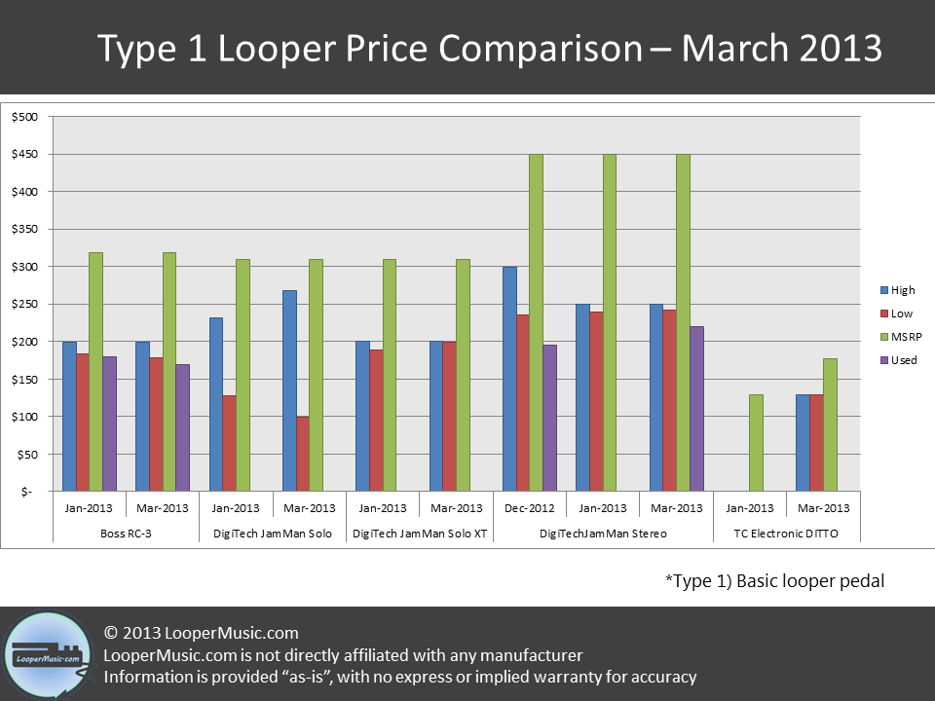
Figure 3.11 Looper Price Comparison
http://loopermusic.com/wp-content/uploads/2012/12/Type-1-Loop-Pedal-March-2013.png

It is also possible to enhance the productivity and the quality of them creating the software version of looper. This was overthought and lots of versions of software loopers were created.

Section 4
Software looper

This section contains the description of existing looper program, shows its advantages and the way how it works.

4.1 General information
According to the last researches, more and more musicians use programs to ease their playing. The programs based on motion recognition are the future of music industry as they provide people with everything they need without any difficulties in consumption.
At present, the dominant technologies behind camera-based interaction systems are motion detection and gesture recognition and, where users’ physical movement is mapped to predefined control signals. An alternative technology is direct manipulation by mirroring the player into the game and giving him/her fully free control via natural body movement. (…)
In this work, we build a prototype system for avatar motion control by natural body movement via a single camera. To bypass object detection, one of the most difficult problems in pure vision, a set of color markers, handy at daily life, is adopted. Together with a 3-D human pose database, the system is able to estimate users’ movement and accordingly control an avatar, meanwhile the avatar is rendered with 3-D motion that most mimics users’ movement. The proposed interaction system could make avatar control natural and immersive. [13]
Just recently, we can see that new computer programs are replacing various mechanical, electronic, electro-mechanical devices, which until recently existed separately.

4.2 Mobius
As an example of similar looper program, Mobius was taken. It is a program for the real-time audio loops creation and editing. It has functionality based on the venerable Echoplex Digital Pro with Loop IV software. It is not a complete emulation, but it does implement many of the Loop IV features, as well as a number of useful new features. Mobius is essentially 8 synchronized stereo EDP's with the ability to copy loops and timing between them. Extensive MIDI and computer keyboard control is available. Audio content may be saved to and loaded from files. [18] It was inspired by the hardware loopers of the past but has lots of advantages which differ it from its ancestors. The power of Mobius is equal to 8 synchronized stereo loopers. According to this, it can replace the whole band.
Users can be satisfied with this program as it is free and has all the access to the editing buttons so that there is an opportunity to extend and change everything what the user wants. It includes virtual musical instruments and has an interesting interface which captures people’s attention. It is comprehensive and that is one more benefit of this program. There is an opportunity to ask questions and report the problems; almost every message will be taken into consideration.
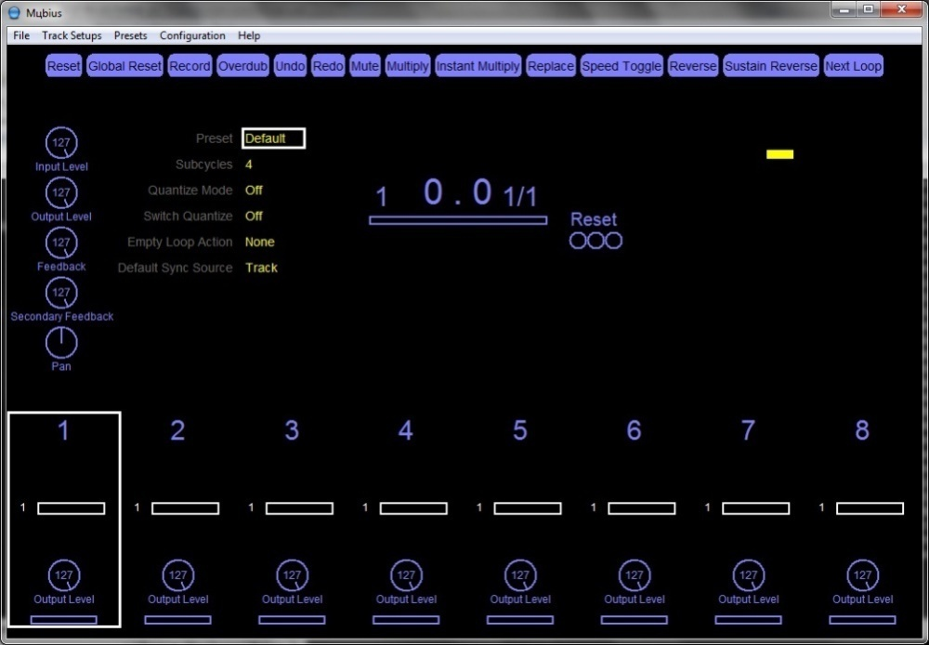
Figure 4.1 Mobius interface

Loop IV is the revolutionary music production software that allows user to compose, record, remix and improve all the ideas he has in the environment of audio/MIDI. It has received lots of awards for its work and fame. The software is easy to use so that it has gathered lots of musicians. They have different forums, where they discuss the software and the whole program, ask questions and answer the questions they faced and know for sure. Until October 2009 Mobius support was supplied by a Yahoo Group.
Mobius is available for both Windows (XP and Vista) and OS X (10.4 or higher). It can be run standalone, as a VST plugin, or as an Audio Unit plugin on OS X. [4]
Designed to emphasize simplicity and hands-on control, short loops of audio can be sliced and transformed with built-in and VST effects. Gesture and Segment sequencers record synchronized loops of knob and button presses, locking effect changes to the loop. Quantized actions and automatic pitch shifting ensure all your loops stay in tempo. Interact directly with the waveform to sculpt your sound, or use the auto-segmenting feature to break it up into equal chunks. MIDI learn is available for any control, and simple knobs provide complete control over the sound of any loop.[14]
The disadvantage is the way of control – only keyboard can be used in this program so there is a need in one more person to press the buttons. This may cause some problems in usage and as a result, recording would need more editing and re-recording.
Features:
- cross platform
- up to 6 files loaded in each looper for the playback
- automatic segmenting
- instantly looping
- multiple audio effects
- easy MIDI learn function
- free of charge
- user-friendly
Section 5
Program description
5.1 Looper description
Section describes the stages of creating the program, peculiarities of used algorithms, description and characteristics of used elements.
While creating the application the main goal was to supply it with the main functions, such as recording and playing the tracks, simultaneous playing a couple of tracks and deleting. Also the opportunity of further improvements for the users was taken into consideration.
The realization of the main functions is shortly explained below:
void recorder::stop(QFile **outfile, quint64 *usecs){
if(current_file == NULL || a_input->state() != QAudio::ActiveState){
qDebug() << "Nothing to stop";
return;
}
qDebug() << "Recorder: Stop";
*usecs = a_input->processedUSecs();
a_input->stop();
*outfile = current_file;
current_file = NULL;
prepare_for_record();
}
void recorder::start(){
if(current_file == NULL){
qDebug() << "Start error, no file prepared";
return;
}
qDebug() << "Recorder: Start";
a_input->start(current_file);
}
The functions given above are responsible for the recording. The second one begins the recording, while the first one stops. The process of recording goes in such a way that the data without closing the file is sent to the player and is played without delays. Such a quality lets to avoid collisions while recording which happen in case of some-seconds gaps in recording/playing.
Another benefit is readiness to record the next track right after the stop. It allows to record non-gap tracks.
void player::notify(){
qDebug() << "Notify! Rewind";
current_file->seek(0);
}
void player::play(QFile *file, quint64 usecs){
if(current_file != NULL || run){
qDebug() << "Player: Cannot start, player already running";
return;
}
qDebug() << "Player: start";
current_file = file;
ulen = usecs;
current_file->seek(0);
a_output->setNotifyInterval((ulen/1000));
a_output->start(current_file);
run = true;
}
These functions given above are responsible for the playing of previously recorded samples. Second function begins the playing and sets the notification on the last millisecond of the track. First function refers to the notification. It turns sample to the start and accurately plays it in circle.
5.2 PCM format description
For storing recorded samples was chosen format PCM, which due to its properties allows to save recorded sound with maximum quality.
PCM format, or Pulse Code Modulation - is the most popular method of representation of the analog signal in digital systems. It is widely distributed in digital signal processing (eg, sound processors), for recording images on an Audio-CD and large number of applications.
PCM sound can be saved with different sampling frequency, it is usually 8 kHz (some standards telephony), 44.1 kHz (CD-Audio), and different resolutions, usually 8, 16, 20, or 24 bits per sample, may represent one channel (monaural sound), 2 channels (dual-channel stereophony) or more (stereophony omnidirectional).

5.3 OpenCV description
OpenCV is released under a BSD license and hence it’s free for both academic and commercial use. It has C++, C, Python and Java interfaces and supports Windows, Linux, Mac OS, iOS and Android. OpenCV was designed for computational efficiency and with a strong focus on real-time applications. Written in optimized C/C++, the library can take advantage of multi-core processing. Enabled with OpenCL, it can take advantage of the hardware acceleration of the underlying heterogeneous compute platform. Adopted all around the world, OpenCV has more than 47 thousand people of user community and estimated number of downloads exceeding 7 million. Usage ranges from interactive art, to mines inspection, stitching maps on the web or through advanced robotics. [16]

This is the library which was created in the Intel Software Development Centre till the first edition. OpenCV is written in the high-level language (C/C++) and contains algorithms for:
- image interpretation
- calibration of the camera as standard
- removal of optical disfiguration
- determination the similarities
- analysis of object’s displacement
- defining of object’s shape
- object’s tracking
- 3D reconstruction
- object’s segmentation
- gestures recognition, etc.
This library is very popular because it is open and there is a possibility to use it for free for studying, working or earning money.
Generally, OpenCV is a number of data, functions and class types for image processing by algorithms of computer vision.
The main library modules:
- CXCORE (contains basical structures od data and algorithms)
  - basic operations with multivariate numerical body
  - matrix algebra, mathematical functions, generators of random numbers
  - recording/recover of data structures in/out of XML
  - basic functions 2D graphics
- CV (module of image processing and computer vision)
  - basic operations with images (filtration, geometrical transformation, transformation of coloured areas, etc.)
  - image analysis
  - analysis of motion, following the objects
  - finding the objects, especially faces
  - calibration of camera, elements of renovating space structure
- HighGUI (module for input/output images and video, creating the user’s interface)
  - capturing the video from camera and video filles, reading/recording permanent images
  - functions for organisation common UI
- Cvaux (experimental and old functions)
  - space vision, stereo calibration, self-calibration
  - stereo-accordance search, klicks in graphs
  - finding and describing face features
- CvCam (video capturing)

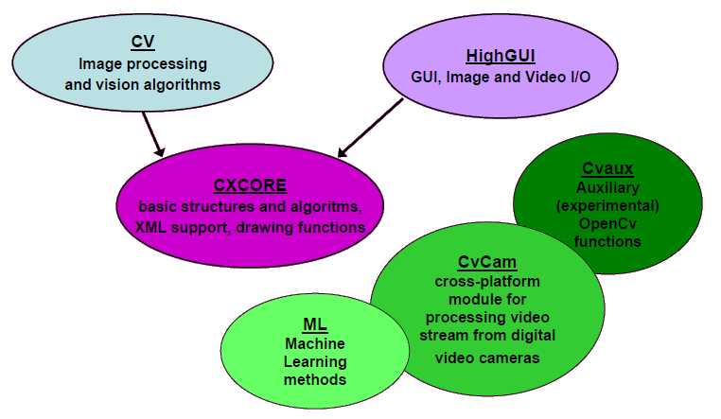
Figure 5.1 CV: Main library modules
http://robocraft.ru/blog/computervision/264.html

5.4 Adding the library Open CV to SDK QT

Library Open CV is a suitable instrument for the projecting visual systems, as it allows getting the image from camera in a very easy way, carrying out the operations on the matrices and vectors, has many ready algorithms, is a multiplatform library.
With QT together, the visual system with solid user interface will be got. As in each operating system OpenCV library is joined differently, it is important to assure that application works correctly, SDK QT has instruments, which help to change the linker definition automatically, depending on the operating system, in which it is compiled. To implement such an automat there is a way: in the option of the project (file *,pro) for the system Windows write win32{} andin curly brackets should be link of library, for Linux unix{} is written. For example:
win32 {
INCLUDEPATH += C:\Programs\OpenCV231\include
CONFIG(release,debug|release){
LIBS += C:\Programs\OpenCV231\lib\opencv_core231.lib \
C:\Programs\OpenCV231\lib\opencv_highgui231.lib \
C:\Programs\OpenCV231\lib\opencv_imgproc231.lib \
}
CONFIG(debug,debug|release){
LIBS +=C:\Programs\OpenCV231\lib\opencv_contrib231d.lib \
C:\Programs\OpenCV231\lib\opencv_core231d.lib \
C:\Programs\OpenCV231\lib\opencv_imgproc231d.lib \

}
}
unix {
LIBS += -I/usr/local/include/opencv -L/usr/local/lib
LIBS += -lopencv_highgui -lopencv_imgproc -lopencv_legacy
LIBS += -lopencv_ml -lopencv_objdetect -lopencv_ts -lopencv_video
}

5.5 Description and conversion RGB in HSV
For colour conversion and reflection the system HSV was set which is described below.
HSV (Hue, Saturation, Value) or HSB (Hue, Saturation, Brightness) – colour model in which coordinates of colour are:
- Hue. Can be coded from 0-360°, but sometimes can be put in the range 0-100 or 0-1. In Windows, all the colour spectre is divided into 240 shades so “Hue” has range 0-240.
- Saturation. Varies within 0-100 or 0-1. The bigger the number the “clearer” the colour so sometimes it is also called “clearness of the colour”. The closer it to zero, the closer colour to the neutral grey.
- Value or Brightness. Also is set within 0-100 or 0-1.

The model was created by Elvis Smith, one of the Pixar creators, in 1978. It is nonlinear transformation of model RGB.

Colour, presented in HSV, depends on the device, in which it should be shown, as HSV – transformation of the model RGB, which also depends on the device. For receiving colour code, not depended on the device, the model Lab is used.

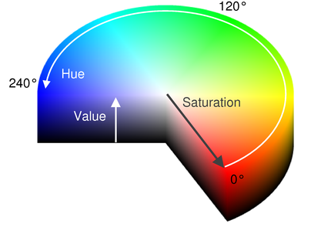
Figure 5.2 3D HSV visualisation
http://robocraft.ru/blog/computervision/402.html

Algorithm of conversion RGB in HSV
It is set that:
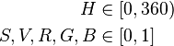 (5.1)
May is maximum meaning of , and , — the minimum.
if
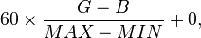 if (5.2) and
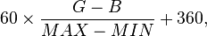 if and (5.3)
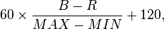 if (5.4)
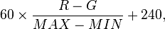 if (5.5)

5.6 Object detection
Algorithm is implemented by chosen characteristic of the object which was its colour. The image received from camera undergoes to the conversion from the RGB space to the colours HSV, as in this area of colours it is easier to define the borders which refer to the object.
After conversion goes bordering, where two borders are given for each of three channels. First border is minimum, in other words, higher values will be enrolled as accepted. Second border – maximum (vice versa).Pixel is accepted when it accomplishes conditions of 2 borders. In the next step algorithm observes all the pixels and if the pixel was accepted but was not marked as a neighbour, it is accepted as a figure pixel. Searching and marking the neighbours starts for this pixel next. After marking all the neighbours of the pixel algorithm compares numbers of neighbours of actual pixel and previous (if it exists) and remembers the coordinate the one, which is bigger. Then, the centre of the figure, to which the pixel refers, is calculated recursively.
The scheme of algorithm’s working is shown below:
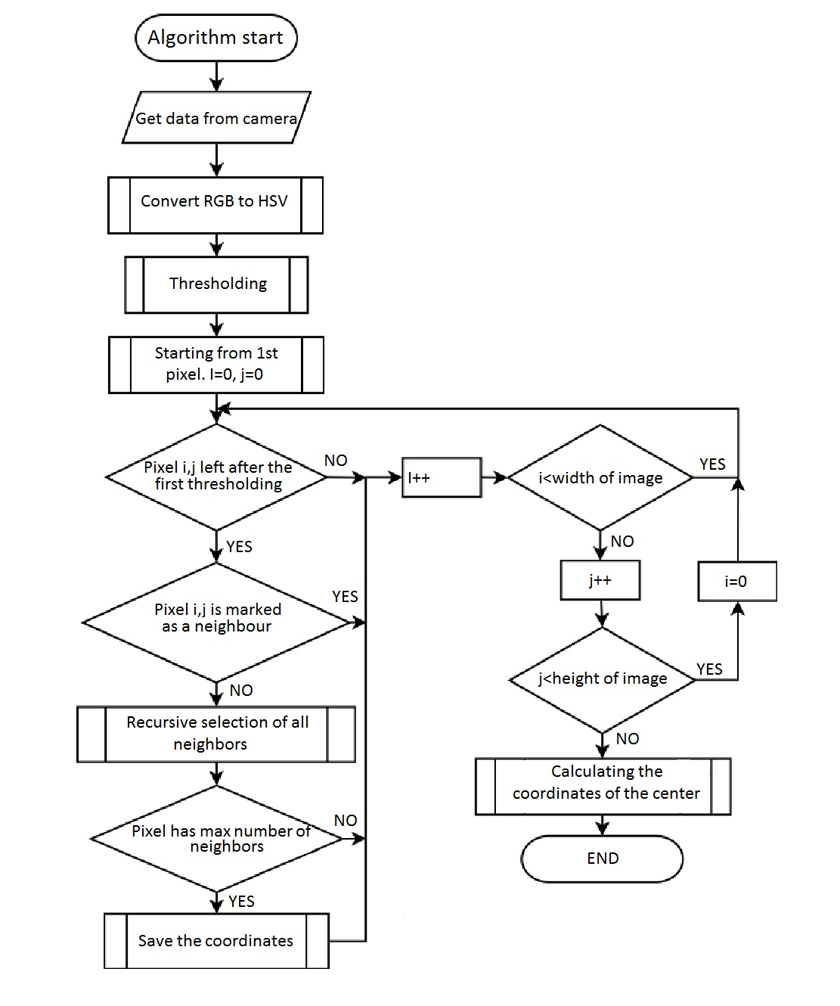Figure 5.3 Algorithm

The problem which appeared during projection such an algorithm was the depth of enclosing in recursion. In the worst case in stack the data was forming with function 640 x 480 pixels. The solution of this issue was creation of the own stack as a table with size 307200x2 (2 means that in stack coordinates x and y, sent to the pixel’s function, are remembered) and moving within it with the help of ordinary variable, which defines the indicator at the top of stack. The use of such method made the algorithm faster and removed the appearance of mistake saying about overfilling the stack.
5.7 Acceptation of movements
In this subsection the features of object motion detection is described. Having analysed all the possible options it was decided to detect the motion by the shot of the camera. As it is known from the following ections, camera snaps no less than 30 shots per second.
In the experimental way it was decided to analyse 12 shots and check them for the direction of motion. 10 out of 12 were chosen and centre dislocation of the object was analysed. If in 10 shots the object moved left or right, program analysed this motion and accepted it as a command.
Less shots (8-10) were not enough for defining the direction, also gave lots of mistaken commands “on/off”. Enlarging the amount of shots more than 15 complicated the work of program as it was hard for the person to make horizontal long-size movement without swinging.
As it is difficult to make clear horizontal or vertical movements in front of camera, it was decided to set the area of deviation on the axel Y within 5 points. So if the movement was along the axel X left or right and the deviation was within the border of allowed values ± 5 pixels along the axel Y the movement also was marked as accepted.
So the flow will look as following:
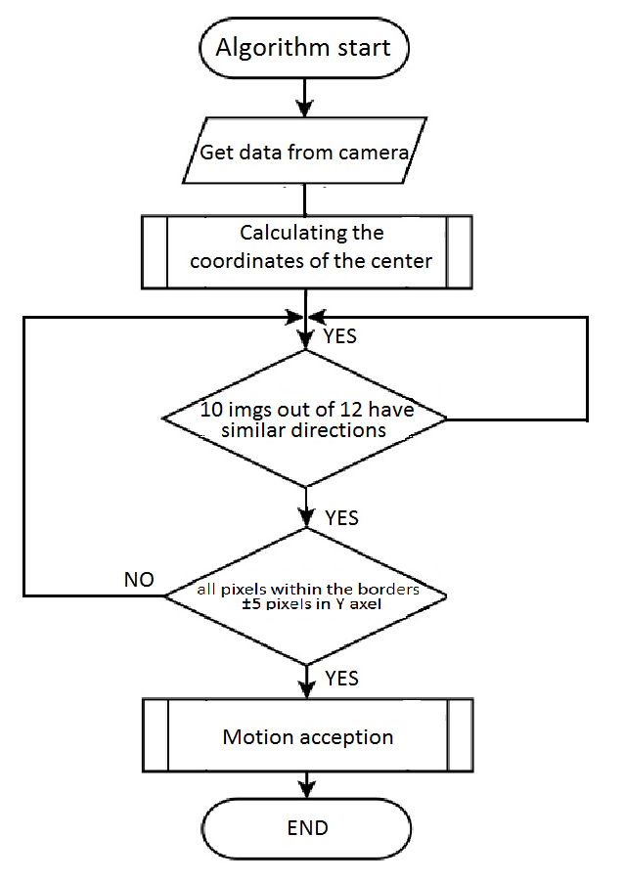
Figure 5.4 Algorithm of motion detection

void QObjectFinder::FindObject(cv::Mat *Image, cv::Point2i *ObjectCenter, std::vector<cv::Point2i> *ObjectPoints,
long MinObjectSize, long MaxObjectSize, intDistanceFromNeighbor)
{
long i, j;
// Pixels of object have coordinate -1, if the object is not found
cv::Point2i PointMax = cv::Point2i(-1,-1);
// Czyszczenie zbioru punktow
ObjectPoints->clear();
// Infilling of work variable
WImg = Image->cols;
HImg = Image->rows;
MinSize = 1000000000;
MaxSize = -1;
uchar *Data = (uchar*)Image->data;
// Copying the original image into working matrix
for(i=0; i<HImg; i++)
for(j=0; j<WImg; j++)
TmpImg[j][i] = Data[i*WImg+j] == 255 ? -1 : 0;
// Overlook of all pixels
for(i=0; i<HImg; i++)
for(j=0; j<WImg; j++)
{
// If actual pixel undergoes the border
if(TmpImg[j][i] == -1)
{
TmpSize = 0;
// Searching and marking the neighbours
if(DistanceFromNeighbor > 1)
FillObj(j,i,DistanceFromNeighbor);
else
FillObj(j,i);
// If object size is acceptable
if(TmpSize<MaxObjectSize && TmpSize>MinObjectSize)
{
if(TmpSize>MaxSize) PointMax = cv::Point2i(j,i);
//if(TmpSize<MinSize) MinSize = TmpSize;
if(TmpSize>MaxSize) MaxSize = TmpSize;
}
}
}
XSum = YSum = 0
if(PointMax.x != -1)
if(DistanceFromNeighbor> 1 )
AddPoints(PointMax.x, PointMax.y, ObjectPoints, DistanceFromNeighbor);
else
AddPoints(PointMax.x, PointMax.y, ObjectPoints);
// Counting the average
if(PointMax.x != -1)
PointMax = cv::Point2i(XSum/MaxSize, YSum/MaxSize);
*ObjectCenter = PointMax;
}

5.8 Interface and main functions
In this part of the section the interface of the program will be overlooked, main functions will be described.
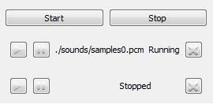
Figure 5.5 Looper control

This window shows the part of the program’s window, which is responsible for recording, replaying and controlling the tracks. Big and convenient buttons of start and stop let to press them fast and accurate with the help of mouse. The size of the buttons allows pressing them even during fast movements. Location of START button left from the STOP button is a logical solution, which is instinctively understandable even for the users who see the program the first time. Right under the START and STOP buttons there is a part of program management. Here are buttons like PLAY, PAUSE and DELETE are located, referring to the playing, stopping and deleting the track. In the middle between PAUSE and DELETE buttons there is information about the track’s status, its name and location in folder.
Figure 5.6 Buttons for image regulation

Picture 5.6 depicts buttons for image regulation. With the help of them the borders for colour recognition are set. Left buttons set low border of recognition, right – high one. Moving left and right button in turns, it is possible to reduce the domain of function. Repeating the regulation of buttons HUE, SAT and VAL it is possible to select the colour which maximum illustrates the object.
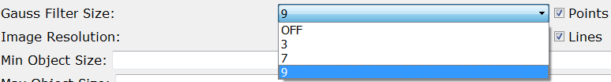
Figure 5.7 Gaussian filter regulations

The part of the window which is responsible for the regulation of Gaussian filter settings. Using the combo box it is possible to set the filter meaning within the border 0-9. The meaning OFF – filter is switched off, the image is analysed without the degradation. The filter meaning 9 – maximum degradation. Gaussian filter turned to be very necessary during the experiment, as allows to degrade all the area perceived by camera, which helps to reflect and analyse the shape and colour of the object, with the help of which the management is done, more qualitatively.
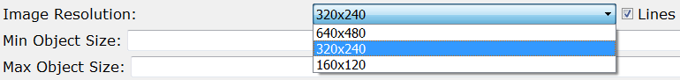
Figure 5.8 Resolution field

Image resolution field is done for the selection of camera resolution. Choosing one of three variables 640x480, 320x240 and 160x120 it is easy to gain maximum legibility or maximum degradation of the image.
Reducing the resolution is helpful for deprivation the small objects of the similar colours, which can worsen the quality of perception.

Figure 5.9 Points and Lines flags

Points and Lines flags switch on the scale reflection and identified area in the screen.
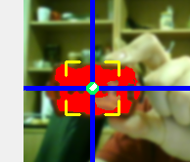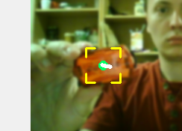
Figure 5.10 Identification of the object’s area

Figure 5.10 displays one and the same object with showing all the lines and points and without them.
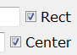
Figure 5.11 Flags Rect and Center
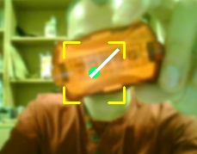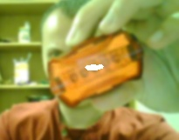
Figure 5.12 Defining the centre

Options Rect and Center switch on the functions of displaying the rectangle around the shown area and appoint the centre. Option appointing the centre is very useful for setting and using the program. Not using this option, the management turns to be very difficult.
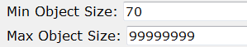
Figure 5.13 Size field

With the help of these fields the size of minimum and maximum recognised object in pixels can be set. Setting the meaning MIN at 70, for example, program would not pay attention to the whole object of chosen colour which contains 70 or less pixels. The mixture of Gaussian filter and such determination in pixels leads to the better recognition of the object, as the full degradation makes colours almost the same.
Within the border of one element similar colour which is not defined by the camera will be identified as a chosen colour after degradation with filter. Similar usage of tools allows to identify the small objects clearly and confidently, “see” better the centre of the object during rotation in space.
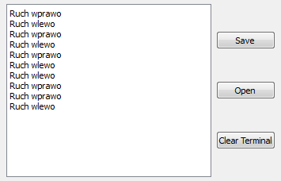
Figure 5.14 Field with motions description

Lower, in the middle part, the main field is located, which displays the statistics of the last motions and their direction in the chronological order. This window is a very useful means of organizing the program, carrying out the tests and also for consuming. On the right there are buttons Save, Open and Clear Terminal for saving colour settings, opening edited colour and removing everything from the terminal.
So, the button Clear removes the history of terminal from all previous actions, it is a helpful tool for setting, and tests generally.
Save button keeps all the colour settings in two options HUE, SAT and VAL. This tool is very convenient for the user as it helps to save the colour settings for the further usage. This option is very useful while using the same object for management as during the next session it is possible to use saved settings. It will save the time reasonably. In case of changing the light intension in the room, small editing will be enough. The usage of possibility to save the colour settings gradually enhances the productivity among the system person-program, eases the consumption and shortens the time for preparations. Tests helped to prove that the time for starting and preparation the program became shorter – from 25-30s to 5-10s thanks to the opportunity to save the settings.
Open button allows to open the settings which were saved before with the help of Save button. There is an opportunity to edit the colours wherever it is wanted and they will always be available for the usage.
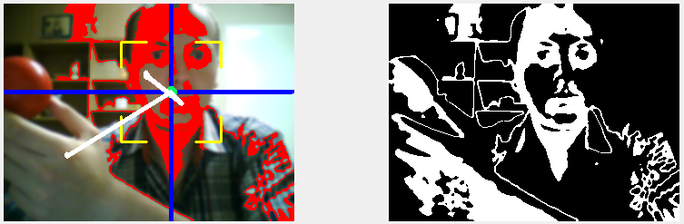
Figure 5.15 Main field

The main place in the window is for the picture field with an image from camera and after thresholding. The image after thresholding turns to be useful for finding the right colour, it shows accurately the parts of the image, perceived by the program.
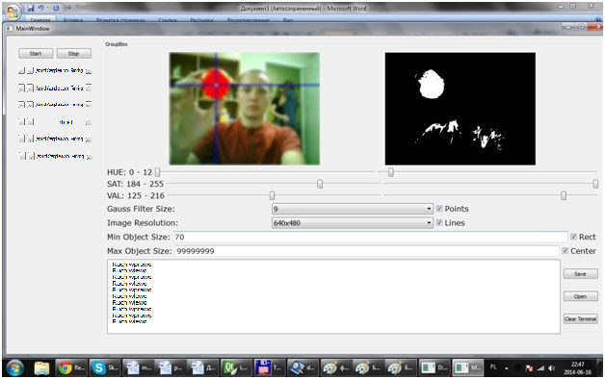
Figure 5.16 Main interface of the program

In the picture above the main interface is shown. That is the view during program’s work and its usage. Such a view have located buttons, tools and fields.

Section 6
Tests and comparisons

During the creation of the program a vast amount of experiments were carried out. The objects with different colours, shape and size were compared. Experiments were done with the help of HAMA PC-Webcam „AC-150”, LogitechC905, built-in laptop web camera ACERCrystalEye.
Standard camera usually has limited field of view (FoV). The video perceived under say a pure translation (of the camera) in the x-direction would be similar to that under a pure left-hand rotation about the y-axis, where the x and y axes are the orthogonal coordinate axes of the image domain. In other words, there would be ambiguity in distinguishing or recovering motion from the video information. If the camera has only limited image resolution and video sampling rate, which is inevitable in practice and which results in error in extracting local flow, the ambiguity becomes inaccuracy in motion recovery. Remedies to the above two issues include using denser sampling rate and wider FoV imaging system. Denser sampling rate could help in determining the flow more precisely at each image position where intensity gradient is present. However, if the scene is not densely textured, which is often the case in practice, the number of feature positions in the image data where flow can be estimated is the same, and there would be a limit of how much of the stated issue is addressed.[8]
The issues were clear and experiments were done regarding to these obstacles.

6.1. Resolution
All the given cameras work in the colour range and allow installing the resolution up to 640х480, which is used by program. All the given cameras with the resolution 640х480 record video no less than 30 fps. During the experiments it was discovered, that camera Logitech C905, which has the best characteristics, showed the worst results in the comparing test. This camera has optics of high quality, produced by the company Carl Zeiss. It is very exact, with good colour determination, high resolution. Camera had great result due to colour determination but the difference was noticeable only in resolution 640x480.
Decreasing the resolution, the difference in quality characteristics levels. Using the resolution 320x240 all the cameras showed almost the same results.
Resolution 160x120 provoked the same results on each camera. Quality of defining the objects, in this case, didn’t change depending on camera.
In all cases, defining the objects was made equally regardless of distance to the object, speed and colour. Experiments were carried out under the equal condition, with the equal level of illumination, with the same objects.

6.2. Light intensity
In order to measure the light intensity Photometer UT381 was used.
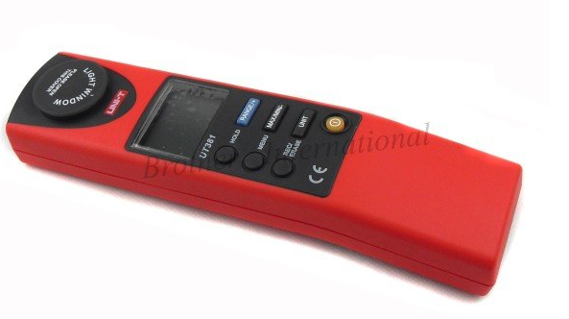
Figure 6.1 Photometer UT381
http://www.aliexpress.com/store/product/UNI-T-20000-Lux-Professional-Luminometers-Light-Meter-Free-shipping/605790_474707653.html

Basic Functions |  | Range | Best Accuracy
Illuminance Measurement | LUX | 20 Lux  200 Lux  2000 Lux  20 000 Lux | ±(3%+20)  ±(3%+8)  ±(3%+8)  ±(3%+8)
Illuminance Measurement | CD | 2 CD  20 CD  200 CD  2000 CD
Special Functions
Working Temperature |  | 0°C-40°C (32°F-104°F) | +
Deposited Temperature |  | -10°C-55°C (14°F-122°F) | +
Relative Humidity |  | ≤7.5% | +
USB |  |  | -
Table 6.1 Photometer characteristics
http://www.aliexpress.com/store/product/UNI-T-20000-Lux-Professional-Luminometers-Light-Meter-Free-shipping/605790_474707653.html

Power | 9V Alkaline Battery x1
LCD Size | 22.5 x 32.5 mm
Product Colour | red and grey
Product Net Weight | 185 g
Product Size | 195 x 45 x 26 mm
Standard Accessories | USB Interface Cable, English Manual, Carrying Bag, Battery
Standard Individual Packing | Blister
Standard Quantity Per Carton | 40 pcs
Standard Carton Measurement | 650 x 560 x 300 mm (0.11 CBM Per Standard Carton)
Standard Carton Gross Weight | 15 kg
Table 6.2Photometer specifications
http://www.aliexpress.com/store/product/UNI-T-20000-Lux-Professional-Luminometers-Light-Meter-Free-shipping/605790_474707653.html

Experiments were carried out on different levels of light intensity: 100, 160, 200, 250, 300 ±15 lux.
Research for defining the optimal level of light intensity was made with the help of red round mat object. The distance to the camera was about 300 mm. Experiment was made on the low speed – about 0.5 m/s, which showed the best result. Next speedup leads to incorrect defining of motion direction due to the lack of needed shots number for the defining it. Diminishing the speed leads to the groundless delays in the control – user needs too much time for commanding the program, which is not always possible. Also, during diminishing, instability of object’s motion in front of camera is possible.

Light intensity | Quality of the image
100 | 80%
160 | 90%
200 | 95%
250 | 90%
300 | 90%
Table 6.3 Light intensity measurements

With the help of experiments it was defined, that the higher level of light intensity was the better program worked. Best result was between 160 and 250 lux. Such properties refer to the common light intensity in the room during the sunny part of the day or when it is lit by the illumination. After enhancing the intensity more than 250 lux, the quality of picture didn’t change. More than 500 lux had the opposite effect – because of too much light position of the object wasn’t recognised correctly.

6.3. Tested objects
There was a variety of tested objects: the shape and colour was different. The chosen objects were following:
- red round object
- yellow rectangular object
- 4 triangular objects (red, purple, green and yellow)

6.3.1 Shape of the object
The peculiarity of program’s work is that it defines the shape of colourful object and finds its centre. Then, defining the posture of the object is made by the location of its centre.
The experiment proves that the shape of the object plays great role in its defining. For example, rectangular object is defined well only if it is held straight in front of camera, avoiding any deviations. Program constantly searches for the centre of object, which location depends on the actual posture.
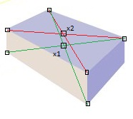
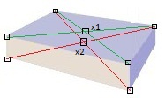
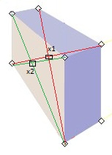
Figure 6. 2 Finding centre of rectangular object while revolving

In the picture above the rectangular object is shown with the particularity in defining its centre depending on its location in space. Analysing those images, it is easy to deduce that rectangular three-dimensional objects in the point of program’s algorithm change their centre during the revolving it in space.
Similar optical effects does not have round spherical object. In any posture its centre is steady and may be defined easily.
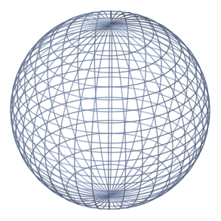
Figure 6.3 Spherical object
http://ru.wikipedia.org/wiki/Сфера

6.3.2. Slope of the object
While carrying out experiments it was discovered that finding and identification flat objects depends on their location in space and illumination. It means that the light which falls on the flat at the certain angle are reflected differently and can also change the shade of colour. This effect is shown below.
For investigating this phenomenon certain experiments with objects of different shape and colour were made. Comparing results are displayed in the table 6.4. During all the experiments with a vast amount of different objects an interesting fact was noticed: when the recognition flat was lopsided from vertical at some angles the quality of recognition reasonably suffered. Some objects were not recognised at all during this experiment. Others were recognised but the area of captured object was small and while moving the program was losing it.
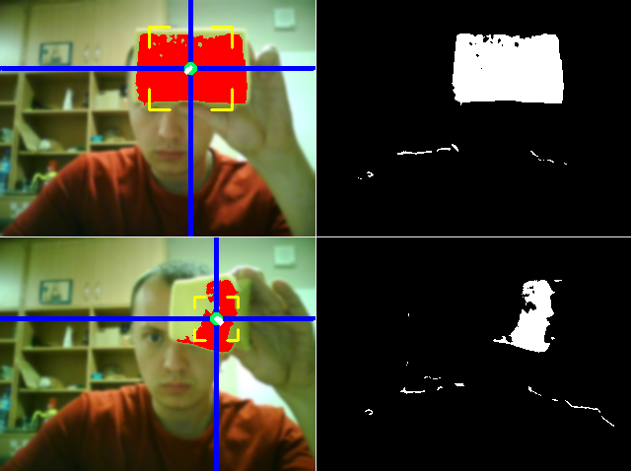
Figure 6.4 Experiment with turning

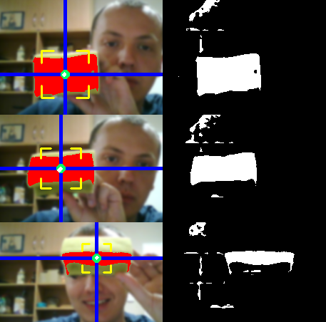
Figure 6.5 Experiment with slope

The image 6.5 depicts one and the same object but with different slope relatively to the horizon.
Experiments were carried out with the help of camera, put in the horizontal position and lopsided at 75° relatively to the horizon. During experiments it turned out that small slope of camera to the light (approximately 15° from the vertical), unlike it was expected, contributed to better object determination. Further angle sloping did not have any better consequences, at the angle 20°-30° the amount of light which reached the lens enlarged, and that worsened the quality of defining the location of objects. The slope 15° relatively to the horizon was taken as the most optimal. Further experiments were made at this slope.
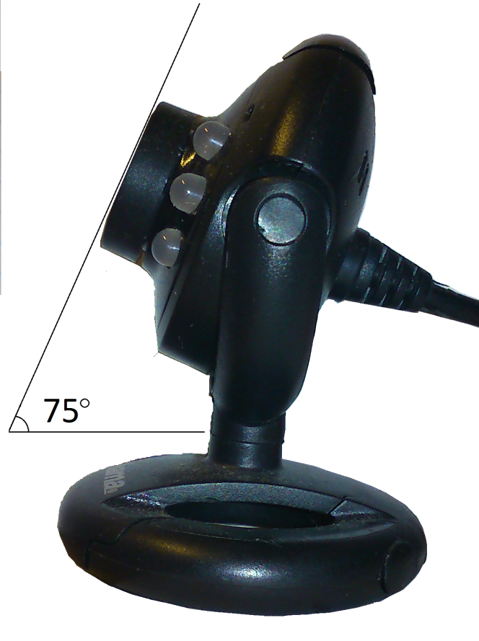
Figure 6.6 The angle of web camera

On the average, the reasonable deterioration of recognising quality happened after lop siding the object at the angle 45°.

Object | Maximum deviation from the vertical
Red mat | 50
Red (glossy) | 42
Yellow mat | 47
Green mat | 44
Green lustrous | 38
Table 6.4 Deviation and centre detection

Table 6.4 shows maximum level of deviation of recognising object from the vertical, after exceeding which object ceases to identify unambiguously, identification turns to be illegible, interrupted and skips to the other objects. As it can be seemed from the table, objects were lopsided relatively to the vertical and at the same time recognising quality was checked.

6.3.3 The texture of the object
The best results were displayed by the objects with the mat flat. Such an effect can be explained as the mat flat reflects the light not so strongly, furthermore, does not depend on colour change because of lop siding. Such a quality of mat elucidates the heterogeneity of flat which seems like it is covered by many grains of colour pigments.
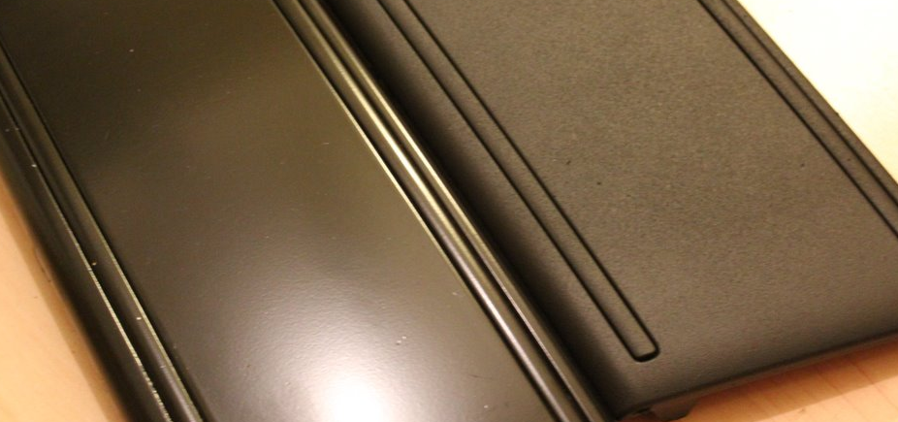
Figure 6.7 Mat and glossy flat

6.3.4 The colour of the object
During the experiment it was discovered, that the best recognition quality have red, bright-green and orange objects. It can be logically explained by the fact, that these objects were the brightest. One more important factor of good colours representation is the fact that they rarely merge with the font and are successfully distinguished from any font colours.
It was discovered that yellow colour often merges with the furniture because it usually has the same colours. Darker objects on the distance and bad illumination can be perceived incorrectly. Sometimes camera does not discern such moving objects from the interior.
Experiments were carried out in the room illumination.

6.4 Results of experiments
When objects are viewed under different angles and different lighting conditions, their image displays photometric and geometric changes. This means that the image colors are different, and geometric deformations like scaling, rotation and skewing have to be taken into account. A variety of approaches exist to be the problem of identifying the presence of the same object under such photometric and/or geometric changes. One way of proceeding is to estimate the transformations and compensate for their effects. An alternative is driving invariant features, that is deriving features that do not change under a given set of transformations. The main advantage of using invariance is that they eliminate expensive parameter estimation steps like camera and light source calibration or color constancy algorithms, as well as the need for normalization steps against the transformations involved. [15]
Based on this information it was decided to investigate the effect of the position of objects, lighting, distance and other factors on how they perceive the camera.
In order to compare the quality and visualize all the results of experiments, there are some tables:
The table shows the percentage of program reactions, depending on various shapes and sizes of the objects. The experiment was conducted with each object in each of the following condition in 20 attempts.
Distance (mm) | red round object | yellow rectangular object | triangle objects
Distance (mm) | red round object | yellow rectangular object | red | purple | green | yellow
100 | 30% | 35% | 30% | 35% | 30% | 35%
150 | 50% | 50% | 50% | 55% | 50% | 55%
200 | 75% | 70% | 75% | 55% | 70% | 55%
250 | 80% | 75% | 80% | 65% | 75% | 60%
300 | 90% | 90% | 85% | 70% | 75% | 75%
Table 6.5 640x480 filter 9

Distance (mm) | red round object | yellow rectangular object | triangle objects
Distance (mm) | red round object | yellow rectangular object | red | purple | green | yellow
100 | 35% | 35% | 35% | 30% | 35% | 30%
150 | 45% | 40% | 45% | 35% | 45% | 35%
200 | 70% | 50% | 55% | 45% | 50% | 40%
250 | 75% | 55% | 60% | 50% | 55% | 50%
300 | 85% | 70% | 75% | 65% | 65% | 70%
Table 6.6 640x480 filter 7
Distance (mm) | red round object | yellow rectangular object | triangle objects
Distance (mm) | red round object | yellow rectangular object | red | purple | green | yellow
100 | 30% | 35% | 30% | 30% | 35% | 35%
150 | 40% | 45% | 50% | 55% | 50% | 50%
200 | 65% | 65% | 65% | 65% | 60% | 55%
250 | 65% | 70% | 75% | 75% | 75% | 65%
300 | 75% | 75% | 80% | 80% | 75% | 70%
Table 6.7 640x480 filter 3

Distance (mm) | red round object | yellow rectangular object | triangle objects
Distance (mm) | red round object | yellow rectangular object | red | purple | green | yellow
100 | 35% | 30% | 30% | 35% | 30% | 30%
150 | 55% | 50% | 55% | 55% | 50% | 40%
200 | 65% | 65% | 75% | 60% | 75% | 55%
250 | 80% | 85% | 85% | 70% | 75% | 65%
300 | 90% | 90% | 90% | 75% | 85% | 80%
Table 6.8 320x240 filter 9

Distance (mm) | red round object | yellow rectangular object | triangle objects
Distance (mm) | red round object | yellow rectangular object | red | purple | green | yellow
100 | 30% | 35% | 35% | 30% | 35% | 30%
150 | 50% | 45% | 45% | 40% | 50% | 40%
200 | 70% | 50% | 60% | 50% | 55% | 45%
250 | 80% | 60% | 65% | 55% | 55% | 55%
300 | 90% | 70% | 75% | 70% | 65% | 75%
Table 6.9 320x240 filter 7

Distance (mm) | red round object | yellow rectangular object | triangle objects
Distance (mm) | red round object | yellow rectangular object | red | purple | green | yellow
100 | 30% | 30% | 35% | 30% | 35% | 30%
150 | 45% | 45% | 45% | 35% | 35% | 45%
200 | 45% | 50% | 50% | 40% | 45% | 45%
250 | 60% | 55% | 60% | 50% | 50% | 55%
300 | 70% | 65% | 65% | 55% | 65% | 65%
Table 6.10 320x240 filter 3

Distance (mm) | red round object | yellow rectangular object | triangle objects
Distance (mm) | red round object | yellow rectangular object | red | purple | green | yellow
100 | 40% | 30% | 35% | 30% | 35% | 35%
150 | 55% | 55% | 50% | 50% | 45% | 50%
200 | 65% | 65% | 55% | 50% | 55% | 55%
250 | 80% | 70% | 65% | 65% | 65% | 60%
300 | 95% | 85% | 75% | 70% | 80% | 75%
Table 6.11 160x120 filter 9

Distance (mm) | red round object | yellow rectangular object | triangle objects
Distance (mm) | red round object | yellow rectangular object | red | purple | green | yellow
100 | 30% | 35% | 30% | 35% | 35% | 30%
150 | 45% | 50% | 45% | 50% | 45% | 40%
200 | 50% | 65% | 45% | 55% | 55% | 45%
250 | 65% | 70% | 60% | 60% | 70% | 55%
300 | 75% | 85% | 70% | 65% | 75% | 65%
Table 6.12 160x120 filter 7

Distance (mm) | red round object | yellow rectangular object | triangle objects
Distance (mm) | red round object | yellow rectangular object | red | purple | green | yellow
100 | 30% | 35% | 30% | 35% | 30% | 35%
150 | 40% | 45% | 35% | 40% | 30% | 45%
200 | 45% | 45% | 45% | 45% | 40% | 45%
250 | 55% | 50% | 60% | 55% | 45% | 60%
300 | 65% | 65% | 70% | 65% | 55% | 65%
Table 6.13 160x120 filter 3

These tables show how the results can vary because of outer factors. Different characteristics influence the quality of recognition and reaction to the commands.
The problem of estimating motion and shape of a moving object has been considered from a time series of image data obtained via perspective projection. First of all, we analyze motion and shape dynamics of a planar surface undergoing rigid motion. It is shown that, for a class of motion parameters, the shape parameters are asymptotically decoupled from the optical flow dynamics, hence, become unobservable, asymptotically. For other choices of motion parameters, shape parameters remain asymptotically observable. [10]
Taking all the facts into consideration, it was proved that mediator can be used for this program; the motion of such a small thing is well detected when the angle and illumination conditions are right.
6.5 Comparison with similar programs
This section will describe looper comparison with similar programs, controlled by gestures. For comparison, were selected following programs:
- Flutter
- Npointer
Flutter is a free program to manage music player, NPointer allows you to perform any operation on the computer using gestures.
The experiments were carried out under illumination within 200-220 lux. Basic movements that are perceived selected programs were replicated. During the experiment was identified the shortcomings of these programs.
Both programs use hands to control identity, which is convenient, but it has some disadvantages among which skin color. The skin on the hands of man has the same color as in other parts of the body, so often a hand coincides with the background (eg head) and impairs response program.
It was also noted that NPointer reacts to movements of the whole body, that one wrong move your head, or your other hand while using the program leads to a deterioration of the results of its work.
In a comparative test was performed on 10 control movements that are understandable for each application. The percentage of positives were recorded. The experiment was repeated several times to check the likelihood of the data.
The results are shown in the table below:
Flutter | NPointer | Tested version of created application
80% | 92% | 88%
Table 6.14 Comparison with similar programs
6.6 Tests with real users
To perform the test, I invited a group of 10 people, which is closely connected to the computer and computer science, and 10 people of other specialties such as mechanical engineering, journalism, law. The first group very quickly understood the basic algorithm of the program, learned to tune it properly used. The second group needed more time to initially explore the program. Sometimes they needed help in settings.
Based on the opinion of the testers it was established that:
- Making the finished product should take into account the target audience of the product.
- People, whose work is closely connected with the world of informatization, quickly learned to work with the program.
- People whose work is related not to the world of information needed some help and tips initially.
- After 10 minutes of using the program, both groups had same results.
The second group also noted the rather important points that can be corrected in the future, during the preparation of the commercial version, including:
- It was noted the lack of information support.
- The audience expressed a desire to have step by step instructions for first use.
- 40% of respondents had difficulty understanding how to configure the colors.
- The audience offered the idea of ​​automatically determining the color of the control object
However, the vast majority of testers (75%) noted application usability, simplicity, reliability. Audiences were marked and some negative points, the most influential is less than 100% of the reaction to human gestures.
It should be noted that a similar effect is present in all systems working with web camera and due to the lack strict connection between the object of control and the system.

Section 7
Conclusions

To sum up, it is important to admit that the software program which I created can be used widely among the musicians as it is convenient and user-friendly. One of the most important factors is easiness in consumption. Trying the application, everyone will find something new and interesting for him
While preparing the master thesis I realized that contemprorary technology has developed rapidly. It allows to create software programs which replace the analogue program. The benefit of computer program is the opportunity ofusing the looper without any extra equipment. It is enough to have a computer with the sound card and web camera to consume my program. With the help of mouse user chooses the necessary mode, wanted characteristics and functions. All the program control is done through the base computer tools, without any need in buying extra devices.
Experiments proved that more than 90% of results were clear and right, the recognition was at the high level. Most of libraries and algorithms were acceptable by users. They had no difficulties to cope with the program. I made some surveys among programmers to find out whether my program is helpful. Most of asked were satisfied with the way of object comprehension and recognition. They agreed that the program work is done well, it is possible to control the looper via moving the object (especially mediator).So I can claim that my software looper will be useful for the musicians, because it combines the latest technology with old proven means giving a new breath to known things

References

[1] Andreopoulos A., Tsotsos J.K., 50 Years of Object Recognition: Directions Forward, v. 117, is. 8, Computer Vision and Image Understanding, August 2013
[2] Blanchette J., Summerfield M., C++ GUI Programming with Qt 4, Prentice Hall, 2006
[3] Bradski G., Learning OpenCV, O’Reilly, 2008
[4] Circular Labs - http://www.circularlabs.com/
[5] Digitech JamMan Express XT - http://www.8thstreet.com/Digitech-JamMan-Express-XT-Full-Featured-Compact-Stereo-Looping-Pedal-pc68593.8th
[6] Gates B., Formatting your Master's thesis in Microsoft Word, Master's thesis in Text Processing, Trondheim, Norvegian University of Science and Technology, 2013
[7] Hopper J., The Girl's Guide to Rocking Out, p. 34, Workman Publishing, 2009 - http://www.8thstreet.com/Digitech-JamMan-Express-XT-Full-Featured-Compact-Stereo-Looping-Pedal-pc68593.8th
[8] Hui T.W., Chung R., Determining shape and motion from non-overlapping multi-camera rig: A direct approach using normal flows, Computer Vision and Image Understanding, , v. 117, is. 8, pp. 947–964, August 2013 – http://www.sciencedirect.com/science/article/pii/S1077314213000933
[9] Instruction Manual 20000 lux UT382 - http://www.uni-trend.com/manual2/UT380%20Eng.pdf
[10] Kano H., Ghosh B.K., Kanai H., Single camera based motion and shape estimation using extended Kalman filtering, Mathematical and Computer Modelling, v. 34, is. 5–6, September 2001 - http://www.sciencedirect.com/science/article/pii/S0895717701000796
[11] Kubiak L., Wykrywanie i śledzenie ruchu obiektów przy pomocy prostych czujników odległości, Praca magisterska, Politechnika Wrocławska, 2008
[12] Kurs z OpenCV, 2012 - http://roboeraft.ru/page/openev/
[13] Li N., Chen C., Wang Q., Song M., Tao D., Li X., Avatar motion control by natural body movement via camera, Neurocomputing, v. 72, is. 1–3, p. 648–652, December 2008 - http://www.sciencedirect.com/science/article/pii/S0925231208003342#bib3
[14] Livid Instruments - http://www.lividinstruments.com/software_looper.php
[15] Mindru F., Tuytelaars T., Gool L.V., Moment invariants for recognition under changing viewpoints and illumination, Computer Vision and Image Understanding, 94 (2004) 3-27
[16] OpenCV - http://opencv.org/
[17] Rafajłowicz E., Rafajłowicz W., Algorytmy przetwarzania obrazów i wstęp do pracy z biblioteką OpenCV, Oficyna Wydawnicza Politechniki Wrocławskiej, 2009.
[18] Software based looping programs - http://www.krispenhartung.com/software-looping.htm
[19] TC Electronic Ditto Looper - http://www.tcelectronic.com/ditto-looper

List of figures

2.1 Looper Price Comparison
3.1 TC Electronic Ditto Looper
3.2 Setup example 1
3.3 Setup example 2
3.4 Setup example 3
3.5 DigitechJamman Express XT
3.6 JamMan: Standard Looping
3.7 JamMan: Multi-Track Looping
3.8 JamMan: Complex Connection
3.9 Boss RC-3
3.10 Boss RC-3: Connection
3.11 Looper Price Comparison
4.1 Mobius interface
5.1 CV: Main library modules
5.2 3D HSV visualisation
5.3 Algorithm
5.4 Algorithm of motion detection
5.5 Looper control
5.6 Buttons for image regulation
5.7 Gaussian filter regulations
5.8 Resolution field
5.9 Points and Lines flags
5.10 Identification of the object’s area
5.11 Flags Rect and Center
5.12 Defining the centre
5.13 Size field
5.14 Field with motions description
5.15 Main field
5.16 Main interface of the program
6.1 Photometer UT381
6. 2 Finding centre of rectangular object while revolving
6.3 Spherical object
6.4 Experiment with turning
6.5 Experiment with slope
6.6 The angle of web camera
6.7 Mat and glossy flat

List of tables

Table 3.1 Ditto Looper characteristics
Table 3.2 Boss RC-3 characteristics
Table 3.3 Comparison of loopers
Table 6.1 Photometer characteristics
Table 6.2 Photometer specifications
Table 6.3 Light intensity measurements
Table 6.4 Deviation and centre detection
Table 6.5 640x480 filter 9
Table 6.6 640x480 filter 7
Table 6.7 640x480 filter 3
Table 6.8 320x240 filter 9
Table 6.9 320x240 filter 7
Table 6.10 320x240 filter 3
Table 6.11 160x120 filter 9
Table 6.12 160x120 filter 7
Table 6.13 160x120 filter 3
Table 6.14 Comparison with similar programs

